# UNLOCKING INSIGHTS INTO THE GLOBAL AIR TRANSPORTATION

INTRODUCTION

OVERVIEW

This Global Air Transportation Network dataset is a comprehensive collection of information on airports, airlines and their routes. It contains information such as names, cities, countries, codes (IATA and Itransport is one of the fastest modes of public transport which connects international boundaries

PURPOSE

Air transport allows people from different countries to cross international boundaries and travel other countries for personal, business, medical, and tourism purposes.CAO) longitudes, latitudes and altitudes of airportstransport is one of the fastest modes of public transport which connects international boundaries. Air transport allows people from different countries to cross international boundaries personal, business, medical, and tourism purposes.

PROBLEM DEFINITION & DESIGN THINKING

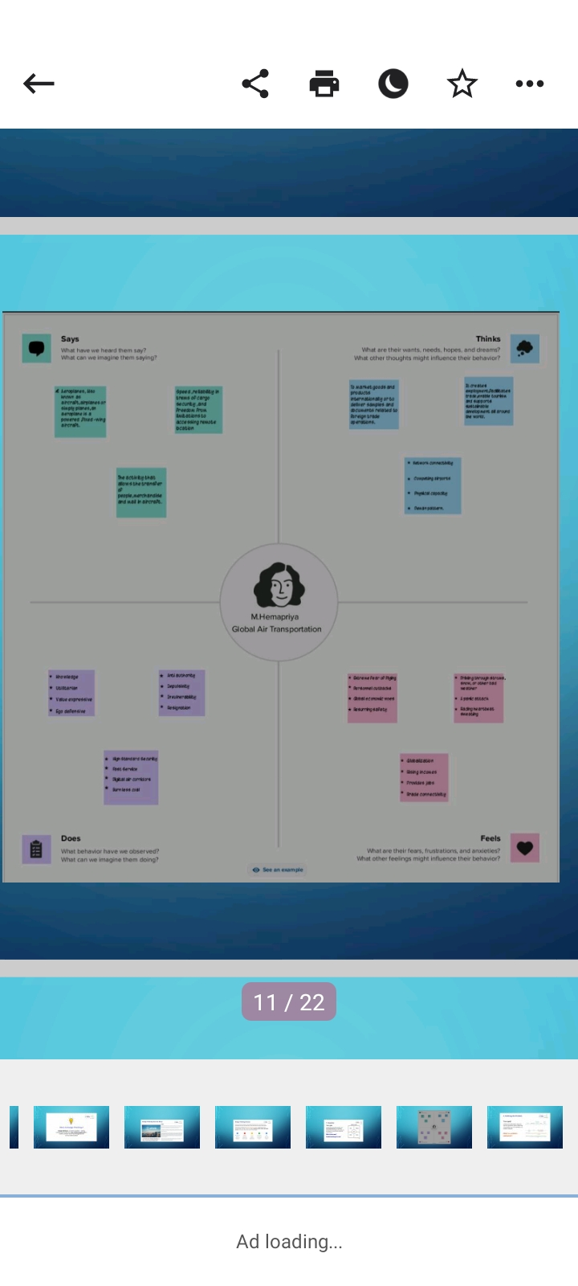



RESULT

By facilitating tourism and trade,it generates economic growth, provides jobs, increase revenues from taxes , and fosters the conservation of protected areas. The air transportation facilitates integration intothe global economy and provides vital connectivity on a national, regional, and international scale.

ADVANTAGES & DISADVANTEGES

Advantages of Air Transport

1. High Speed

2. Fast Service

3. Send almost everywhere your freight

4. High Standard of Security

5. Natural Route

6. There is less need for heavy packaging

Disadvantages of Air Transport

1. Risky

2. Cost

3. Some Product Limitation

4. Capacity for Small Carriage

5. Enormous investment

APPLICATION

Air transport is currently used in almost all industrial sectors and distribution chains. Most companies use air transport to market goods and products internationally or to deliver samples and documents related to foreign trade operations.

CONCLUSION

The air transport industry is not only a vital engine of global socio-economic growth but is also of vital importance as a catalyst for economic development in most countries and for many regions within each country. Its importance arises not only from its ability to facilitate the movement of people but also its ability to expedite the movement of goods. Currently, rising operating costs, stoked by the high price of aviation fuel combined with slowing or even negative demand growth, will lead to dramatic restructuring of the airline industry and the collapse of many airlines especially smaller ones. Reduced access to air services for both passengers and freight may put many communities at a disadvantage.

FUTURE SCOPE

The industry has a number of domestic and international airlines, as well as a large network of airports. The future of the aviation industry in India is likely to see continued growth and expansion, driven by factors such as a growing middle class, increased tourism, and government policies supporting the industry.